Programming languages have been around in some way shape or form for a very long time. Punch cards were first used to program looms in 1801 to create intricate patterns in weaves. Later, Charles Babbage created a proposal for a computer called the “Analytical Engine” which was broken down by Ada Lovelace to create the first programming language. Her language was purely mathematical and was used to calculate Bernoulli numbers on the Analytical Engine. The concepts of these theoretical machines and languages were eventually adapted by Alan Turing and Alonzo Church to create the “Turing Machine” and “Lambda Calculus”. These, along with other theoretical research, paved the way for some of the earliest true programming languages, mainly FORTRAN, which was released in 1957 as the first high-level programming language. After FORTRAN came many others, LISP, COBOL, ALGOL, and many more. In 1973, C was first released by Bell Labs and became the predecessor for many of the modern programming languages we see today, including Java, C++, JavaScript, C#, and many more. Eventually came the birth of the internet, which spawned new languages like PHP and JavaScript. New languages are constantly appearing and disappearing nowadays, and we always see up and coming languages in different fields. We see languages like Swift and Go appearing for platform specific development, Python and R blowing up in the firsts of machine learning and artificial intelligence, Ruby on Rails and Node.js being used in server-side web development. New languages and frameworks like this are constantly appearing disappearing, and it creates interesting trends in the popularity of different programming languages.

There’s many different places you can go to find “Top 10 programming languages of 2017” or articles akin to that, but looking at reliable data sources of data for this, what do we find? Looking at GitHub repository statistics and the Tiobe Index, which is a reliable source that pulls data from search trends across major search engines, Wikipedia, Amazon and YouTube, we can find some of the most popular languages and see how they trend.

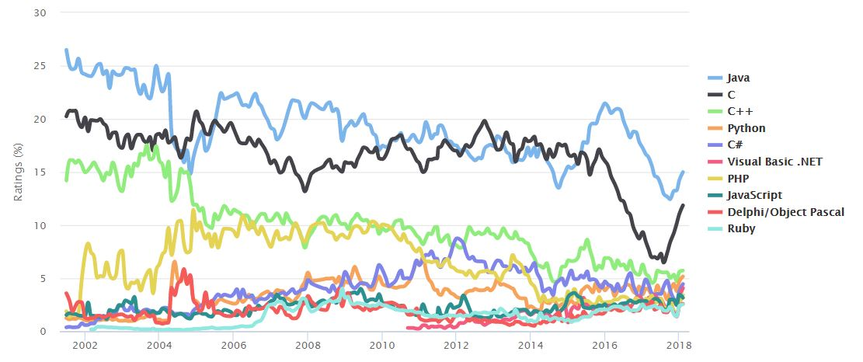

Figure : Tiobe Index of top 10 programming languages

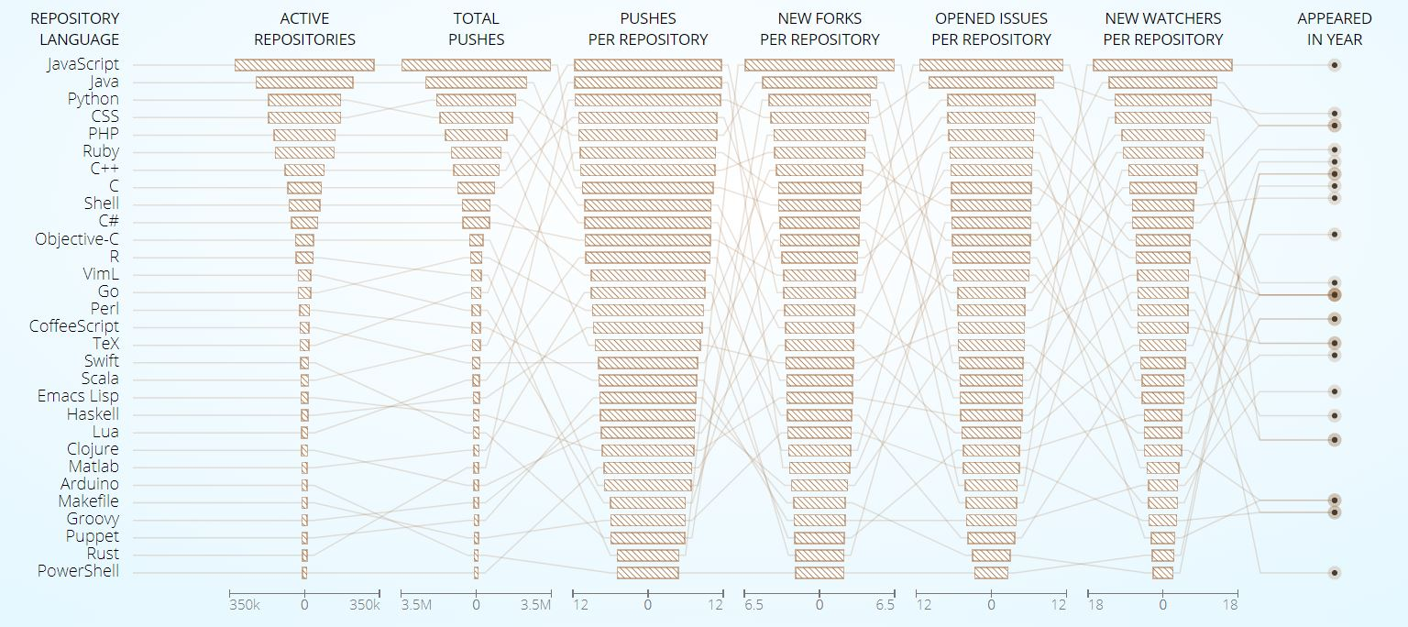

Figure : GitHub stats for most popular programming languages.

We can see in these two images that some of the common top languages are Java, C, C++, Python, C#, PHP, JavaScript, and Ruby. All 8 of these languages appear in the top 10 of these two lists, and I’m going to try and look at some of the similarities between the languages.

Note: I’ve excluded CSS from the top 10 in GitHub since it’s not a true programming language. It is technically Turing complete, however is never used as such.

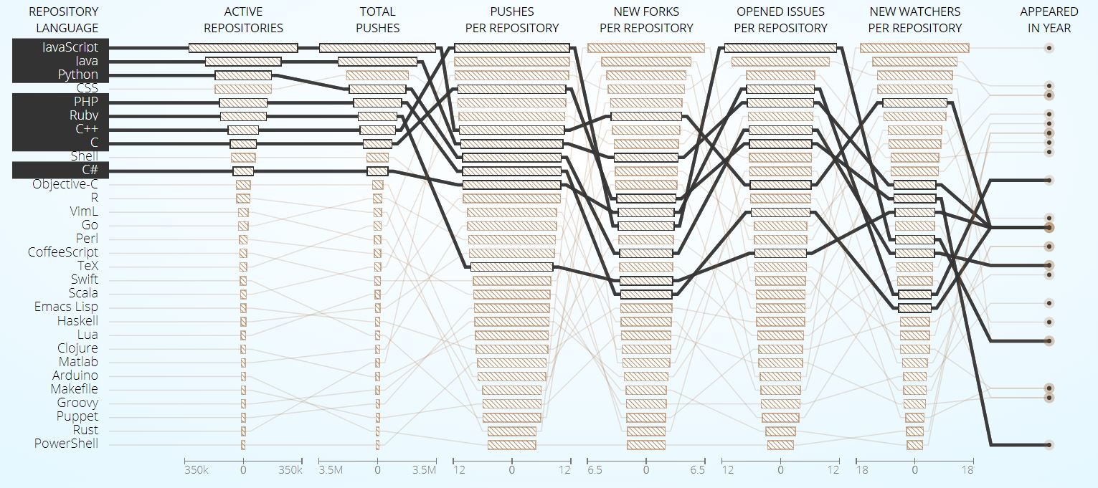

Figure : GitHub stats for 8 similar languages with the Tiobe index.

Most of these languages were made between 1991 and 2000, except for C and C++. This is interesting, because most of these languages are not newer ones like Swift, Rust or Go, but rather the older ones that have been around for 20+ years. We also notice that six of these languages have the familiar C-style syntax. But what else do these languages have in common?

Looking at programming paradigms, we can see that all of these languages, with the exception of C, support Object-Oriented Programming. All of them also support procedural programming, and a good chunk of them, including JavaScript, Python, PHP and Ruby also support functional, with newer versions of Java and C# also supporting basic functional concepts like closures (lambda functions). All of these languages cover many different paradigms, multiple different domain applications, support familiar syntaxes, and having all been made 15+ years ago, have gained traction in the community to have support. This has lead to these 8 languages being huge in the industry today, and most of them won’t be going anywhere for the time being.

Java is still huge in enterprise scale applications, with an estimated 75+% of fortune 500 companies using it for many different purposes. It’s also the primary language being used for Android development, and the language that a lot of colleges and universities are still opting to teach first. JavaScript is the language that the web runs on. Interactive and dynamic web applications wouldn’t exist without JavaScript, and it’s being used more and more on the server side in Node.js and Electron development. Python is growing in machine learning, big data and artificial intelligence, etc. The industry influence that each of these languages has had keeps going, and they have the kind of support that they need to stick around for many more years to come.

We see languages everywhere that draw inspiration from these 8 languages. C++ was made as an improvement to C, and Java made to fix a lot of the issues in C++. PHP was originally made as a web library for C that turned into its own language. A lot of these languages draw inspiration from each other, and dozens of new languages that spawn every year from each of these. Going back to the mention of Swift, Rust and Go, if we look at the syntax and features of these languages, they all share a lot of similarities with the top 8. They’re all syntactically similar, touch on a lot of the big paradigms and all have large companies backing them giving them the library and documentation support needed to grow.